1. Identify what design pattern has been used in the following UML diagram:

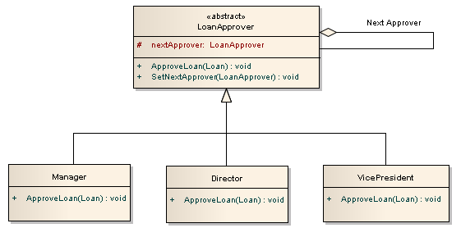

* Object Pool
* **Chain of Responsibility**
* Composite
* Iterator

1. An operation accepts different payment methods, which DP is more suitable to use

* Adapter
* Chain of Responsibility
* State
* **Strategy**

1. There is one creational design pattern in the following list. Which one is it?

* **Object pool**
* Decorator
* Composite
* Template method

1. What is the Object pool pattern good for?

* You must create objects that are expensive to create.
* The frequency of creating further objects is also high.
* The number of objects in use is small.
* **All of the Above**

1. What is true regarding the Object pool design pattern?

* At any given moment the object can be accessed from all clients
* It cannot provide the limit for the maximum number of created objects
* **Object pools are usually singletons**
* Inadequate resetting of objects may not cause an information leak

1. Real-World Analogy

Imagine a seasoned insurance agent who’s eager to get new customers. He can visit every building in a neighborhood, trying to sell insurance to everyone he meets. Depending on the type of organization that occupies the building, he can offer specialized insurance policies:

If it’s a residential building, he sells medical insurance.

If it’s a bank, he sells theft insurance.

If it’s a coffee shop, he sells fire and flood insurance.

* **Visitor**
* Abstract Factory
* Builder
* Bridge